Instructions

Complete all the questions in the space provided. The programs are designed to provide examples that you will be using in your own programs.

**Question #1:**

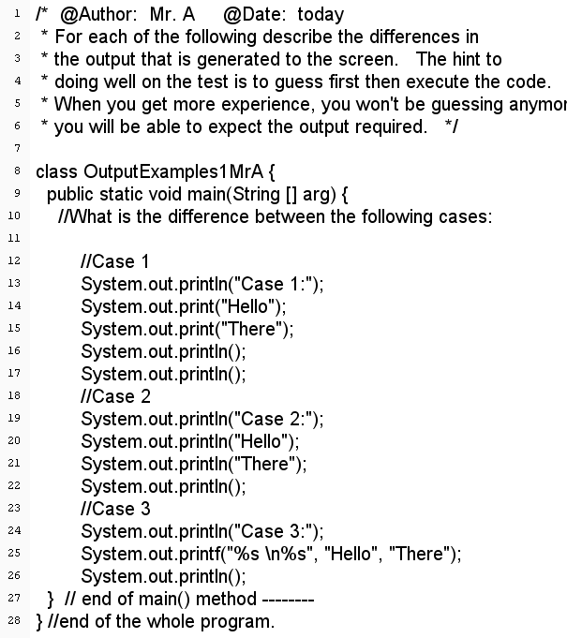

|  |
| --- |
| 1. What is the main difference if any between the three cases?   Case 1: Prints hello there on 1 line(Print)  Case 2: Prints Hello There on 2 lines (Println)  Case 3: Prints Hello There using variables (Printf) |
| 1. What does System.out.println(); do?   It automatically makes a new line |
| 1. What does the symbol \n do?   \n makes a new line just like println |

**Question #2:**

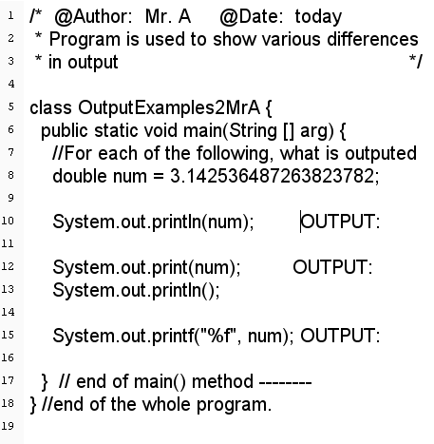

//

//

//

|  |
| --- |
| 1. What does System.out.println(num) display?   It prints “3.1425364872638237” prints up to 16 decimal spots |
| 1. What does System.out.print(num) display?   Also prints up to 16 decimal spots |
| 1. What does System.out.printf(“%f”,num) display?   Only prints up to 6 decimal spots but rounds up |
| 1. Are all the outputs are the same?   No |
| 1. What happens if you change c) System.out.printf(“%f”, num) to System.out.printf(“%d”, num)?   You get an error due to %d being for intigers why %f is for floats |

**Question 3:**

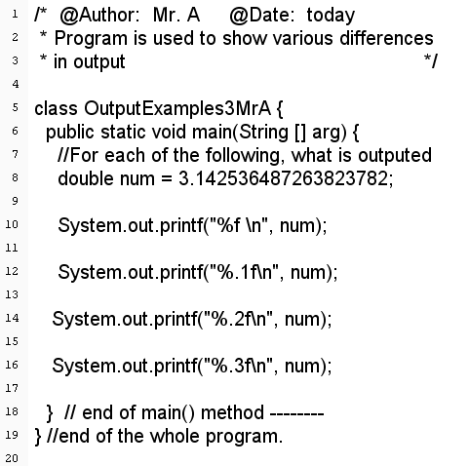

|  |
| --- |
| 1. What does System.out.printf("%f\n", num) display?   It prints num but up to only 6 decimal spots and creates a new line |
| 1. What does System.out.printf("%.1f\n", num) display?   Only displays 3.1 due to being limited to 1 decimal spot |
| 1. What does System.out.printf("%.2f\n", num) display?   Displays 3.14 due to being limited to 2 decimal spots |
| 1. What does System.out.printf("%.3f\n", num) display?   Displays 3.143 due to being limited to 3 decimal spot and rounding up |
| 1. What will System.out.printf(“%.5f”, num) display? What is the significance of the .5?   It will display 3.14254 due to being limited to 5 decimal spots. The .5 says how many spots to limit it to |

**Question 4**

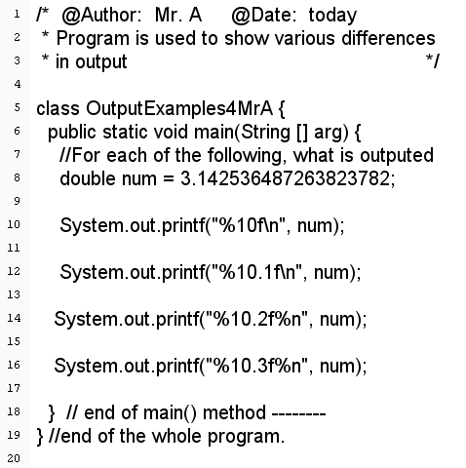

|  |
| --- |
| 1. What does System.out.printf(“%10f\n”, num) display?   This spaces it out by 10 spaces before printing it out |
| 1. What does System.out.printf(“%10.1f\n”, num) display?   This spaces it out by 10 but limits it to 1 decimal spot |
| 1. What does System.out.printf(“%10.2f%n”, num) display?   Spaces it out by 10 and limits it to 2 decimal spots |
| 1. What does System.out.printf(%10.3f%n”, num) display?   Spaces it out by 10 and has 3 decimal spots |
| 1. What does %n do inside the quotes? What symbol is it like?   It creates a new line due to being similar to \n |

**Question #5**

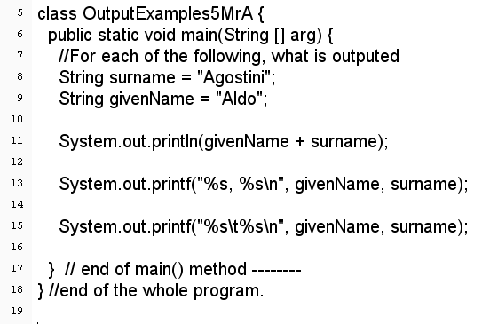

|  |
| --- |
| 1. What is the output System.out.println(givenName+surname);   AldoAgostini due to not providing any spaces |
| 1. What is the output System.out.printf(“%s, %s\n”, givenName, surname);   Aldo, Agostini this is because its provided a space |
| 1. What is the output System.out.printf(“%s\t%s\n”, givenName, surname);   Aldo Agostini due to having \t giving it 5 spaces |
| 1. What does \t seem to do?   \t adds 5 spaces doing the same thing as the tab button |

**Question 6:**

What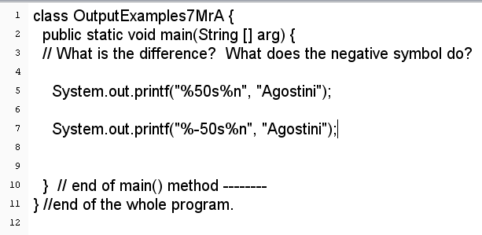

|  |
| --- |
| What is the difference between the output of line 5 and line 7? So what effectively does the negative sign do? What about the 50? What does the 50 do?  The 50 makes it space out by 50 spaces then write it at the end  -50 does the same thing but writes at the start |

**Question #7**

Complete the program below so that it will produce the following output.

